


Report to Governors.
Date of report: July 2023

SENCO: Jen Panton SEND Governor: Jacqui Powell

SEND profile for the last 12 months

2022 -23
Number on roll
St Matthew’s C of E Primary School | 203
National Average | 281
% of pupils with SEND Support
St Matthew’s C of E Primary School | 15%
National | 13%
% of pupils with EHCP
St Matthew’s C of E Primary School | 3%
National | 2.3%
National figures are based on Census data published by the D of E, dated June 2023

During the academic year 2022-23 St Matthew’s had a percentage of pupils with an EHCP above the national average. St Matthew’s has a higher percentage of children on the SEND register.

• 30 pupils on SEND register , including 7 with Education Health and Care Plans

• number of children on SEND register who are also Pupil Premium is 16 (53% of children on SEN register)
• Nationally, boys have a higher likelihood of having SEND. This gender difference is evident at St Matthew’s, where 40 % of children on SEN register are female, 60 % are male.
Free School Meals
Nationally, pupils with SEND are more likely to be eligible for free school meals (30.9%) At St Matthew’s this higher at 53%.
71% of children with an EHCP are eligible for free school meals.

Attendance
Attendance for pupils with SEND is 90.5%

Areas of Need.

Nationally, the most common area of special need for children with EHCPs is Autistic Spectrum Disorder. This is echoed in the EHCPs given to children at St Matthew’s.

On the SEN register in general we have,
7 children (23%) whose primary need is communication and interaction
13 children (45%) whose primary need is cognition and learning
10 children (32%) whose primary need is Social, Emotional and Mental Health. This is the area with the most increase in need for us.

4 children came off register and 3 were added.

The St Matthew’s annual upward trend for EHCP applications is reflected in the National data, which shows a large rise. 3 children with MPP have had EHCP application refused, two of these decisions were overturned after mediation was sought.

At the beginning of the year, we had one child attending an alternative provision setting for 2 days a week. This has ended and the child is successfully attending St Matthew’s full-time now.

The school continues to be committed to seeking early referral to outside agencies such as EP, Early Help, Pediatrics, inclusion, SCAAS and SALT and supporting parents to attend appointments and interpret
Overall quality of provision for pupils with SEND
• outcomes for pupils with SEND (academic and wider outcomes)
This year we have put an emphasis on adaptive teaching. We aim to give our children with SEN the support they need to access the learning with their peers, using the same ‘sticky knowledge’ but documenting and applying their knowledge in different ways. Children regularly use assisted technology, for example, dictating into an iPad.

Identifying pupils with SEND
Pupils with SEND continue to be identified initially by the class teacher, based on observation and assessment. In the case of EYFS, children will often be identified as having SEND needs by their pre-school setting or parents at transition meetings. In the case of in year admissions, parents and previous school are providing information on SEND. SENCO updates register with Early Help with parent consent.
Pupils are first identified through conversation with the SENCO and pupil progress meetings with deputy head and class teacher. Concerns are shared with parents and the Graduated Pathway of response outlined. With consent, a My Plan is then drawn up identifying needs, outcomes, actions, and resources. Interventions focus on achieving outcomes for a 6 to 8 week block. These are reviewed with SENCO, class teachers, TAs, child and parents.
If improvement is not evident after 2 reviewed cycles of My Plans, the pupil is placed on a My Plan Plus. At this point the SENCO will complete a My Assessment with parents, setting out the child’s ‘story’ in some detail, including health needs, family composition and the details of any outside agencies, such as Pediatrics or Occupational Therapy, who may already have been involved. These are updated where child or family experience any changes. Child is supported to complete ‘My journey.’
The My Assessment document is a working document and should be updated throughout the child’s schooling. It provides a useful chronology and summary, which can be shared at outside agency appointments.
The SENCO and class teacher then decide which professionals to contact for additional advice/ assessment and referrals are made, with the agreement of parents and the signing of a Single Consent form to share information.
When the pupil has been seen by outside agencies and a report received (example: Advisory Teaching, Educational Psychology, Speech Therapist) a My Plan Plus is drawn up to incorporate professional advice regarding personalized interventions and approaches.
Again, at least two rigorously delivered and reviewed cycles of My Plan Plus, need to occur before a request for Statutory Assessment can be made and consideration for an EHCP and funding begin.
At all stages of the identification process, communication with parents is key, as SEND and its processes can be complicated and lengthy.
effectiveness of leadership and management for SEND
With support from Head, Deputy and SEND governor, SENCo has conducted observations, training and work scrutiny throughout the school. There is now a plan in place for the identification of children with SEN by teachers and the referral system is used to highlight concerns. SENCo attends meetings both the LEA and DGAT to keep up to date with developments and share good practice. The SEN governor is very involved in the

• quality of teaching, learning and assessment for pupils with SEND
Through work scrutiny, lesson visits and data scrutiny, we are confident that the teaching, learning and assessment meets the needs of the children with SEN.

• personal development, behaviour and welfare of pupils with SEND
Behaviour of children with SEND is a strength, children want to learn and display positive learning behaviours. This has been evidenced in pupil voice sessions. The behaviour system is largely used across the school for all pupils. 3 children have separate, individual behaviour plans.
Achievement of pupils with SEND:
- statutory assessment data

Year 2.
20% of children on SEN register were assessed to have reached age related expectations in Maths and 20% were assessed to have reached age related expectations in Reading.

Year 6
42% of children on SEN register achieved ARE in reading test, 29% in Maths and 29% in SPAG.

- school tracking data

School data shows that all children on the SEN register are making progress.
The use of Target Tracker software to create stepped pupil achievement data is monitored termly. The last data drop took place at the end of 6th July 2023. School moving over to SONAR with DGAT.
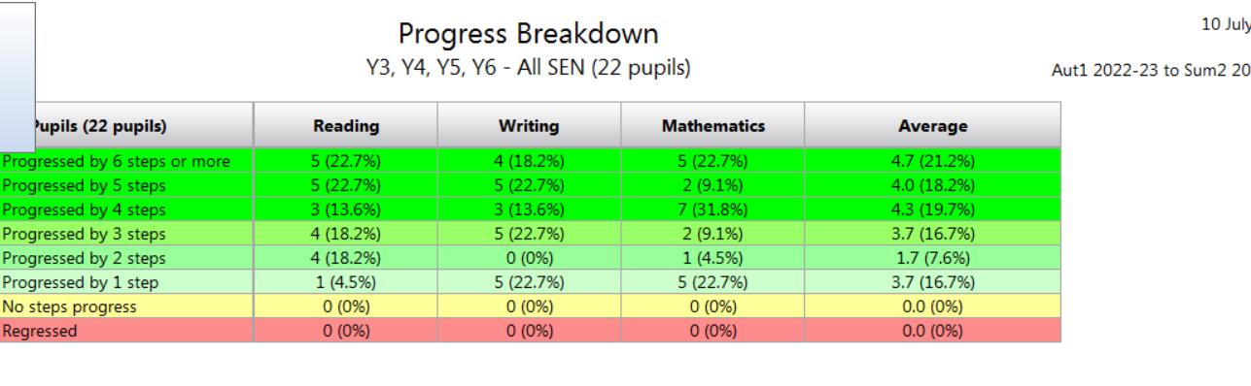

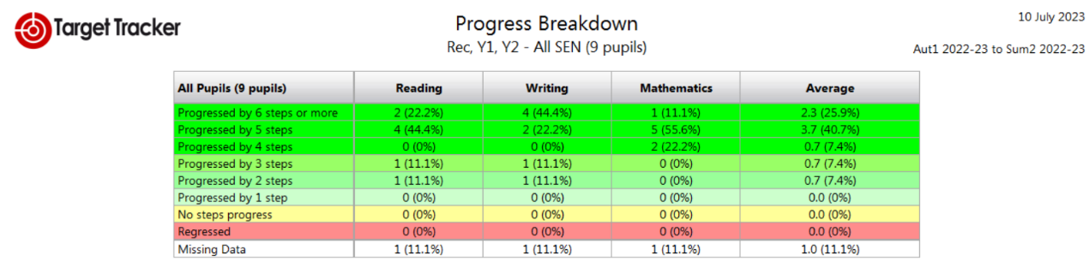

Two of our Year 6 cohort who have EHCPs are going to Alderman Knight School to continue their education. No exclusions have been made this year.

SEND policy
SEND policy was reviewed and updated in June 2023.
SEND information report on school website was reviewed in October 2022.

Staffing for SEND
SENCo has successfully completed the master’s level NASENCo qualification from Best Practice through Bath Spa University.
Dyslexia training has been given to all teachers and TAs from the Dyslexia Society and Bath Spa University.
We have employed two 1:1 teaching assistants to work with children with an EHCP.

Interventions
Interventions are tracked and monitored by the SENCo. A central record of which child is accessing which intervention is held by the SENCo. There is a mixture of small group and individual interventions delivered by both teachers and teaching assistants. Precision teaching is being utilised throughout the school to target gap filling for phonics and maths facts knowledge.
CPD related to SEND
Dyslexia training has been given to all teachers and TAs from the Dyslexia Society and Bath Spa University, which has helped in the identification and support given to children.
TAs have been given phonics training by our reading lead, which has resulted in more focused interventions for phonics.
Staff continued to access a comprehensive range of training opportunities throughout the academic year, making use of the many provider’s CPD courses.
These included:
First Aid
Safeguarding
Child Protection
Nurture
SONAR

Engagement with stakeholders
Pupil voice: Pupils are involved in EHCP and MyPlan+ reviews, telling us what helps them to learn and what are their barriers to learning.
Parent/carer voice: Parents attend MyPlan+ and EHCP reviews. We have an open door policy and the SENCo is happy to discuss any problems as they arise.

Multi-agency work: The school has worked with the speech therapy and occupational therapy services, and a private Educational Psychologist. We have also been well supported by the Advisory Teaching Service, in particular Nicky Davis (who comes in to see 4 different children) and Lorna Hill (who advises us on one child).
The 4 children in the school are supported in their speech and language by Felicity Morris, who visits the school regularly.

SENCO works with SENCOs from Maidenhill and Archway in order to assist with transition for Year

SEND funding
SEND funding is allocated at the beginning of the year to support pupils’ with SEND. Staffing and resources are identified and costed based on needs. SEND funding supports a full time TA in each class. There is no separate SEND budget. The school’s budget, including SEND allocation, is monitored closely by Governors and DGAT.

Complaints
There have been no complaints made.

Any other developments regarding SEND?
The LEA are changing their model for EHCP applications, so we now have a named caseworker working with the school. We also now have a named Educational psychologist, Georgina Sim. It is hoped that these direct contacts will speed up the processes and allow children to be assessed more quickly.
Priorities for the next academic year 2023/24 include:

- Preparation of at least one Statutory Assessment Request
- Embedding the provision for SEN children in the classroom in foundation subjects, ensuring that all lessons are accessible for all students at all times.
- Assessment of potential SEND pupils who have transferred from other schools
- Reading and Writing focus on the lowest 20% of attainers.
- Test repeated in June.
- Can Do Maths half termly Assessment to highlight Maths knowledge gaps. Close the Gap teaching activities planned and delivered by TA.
- Use of Boxall profile to identify developmental needs for children attending nurture groups.
- Change the structure of the pastoral intervention system
- Securing Early Help services for children and families with significant ACES
- Reviewing My Plans, EHCP. Discussing and reflecting on provision and outlining new actions to support outcomes.
- Staff training for child with specific medical need coming into Reception class.

