A World Turned
Upside Down

Religious Education
Islam
Allah - God in Islam
Quran - Islamic holy book
Pillars of Islam - Islamic guidelines to living a full life.
Mecca - The birthplace of Islam.

Christianity
Holy Week - The week surrounding Jesus’ resurrection.
Resurrection - rebirth. Jesus returning to Earth.
Salvation - being saved by Jesus from sin.
Crucifixion - Jesus placed on a cross.

Key People
Captain Cook - 1728 - 1779
An English explorer who discovered the East coast of Australia.
Edward Budding - 1796 - 1846
An inventor who lived in Eastington, Stroud. Known for the invention of the lawnmower and the adjustable spanner.

Key Dates
1770 - Captain James Cook charts the east coast of Australia and claims it as a British possession.
1901 - The Commonwealth of Australia is created.
Vocabulary | Definition
Habitat | A place where an animal or plant lives.
Predator | An animal that hunts other animals for food.
Prey | An animal that is hunted for food.
Herbivore | An animal that only eats plants.
Carnivore | An animal which only eats meat.
Omnivore | An animal that eats both plants and meat.
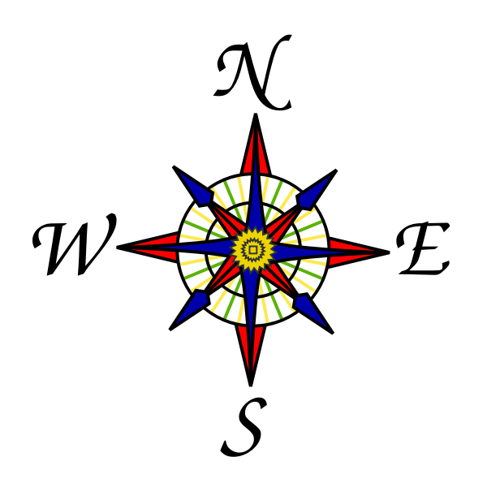
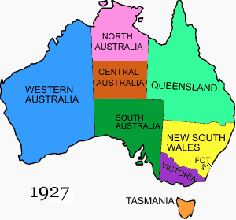

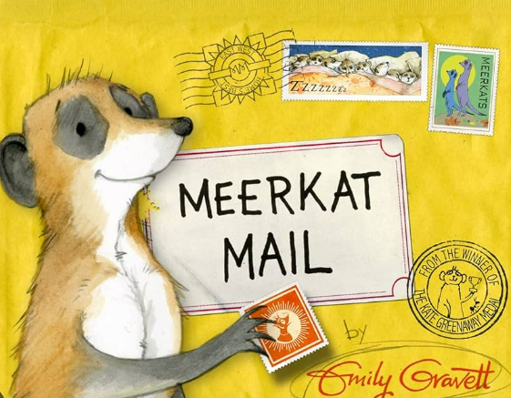
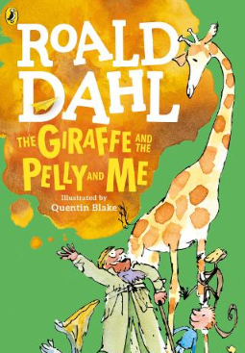
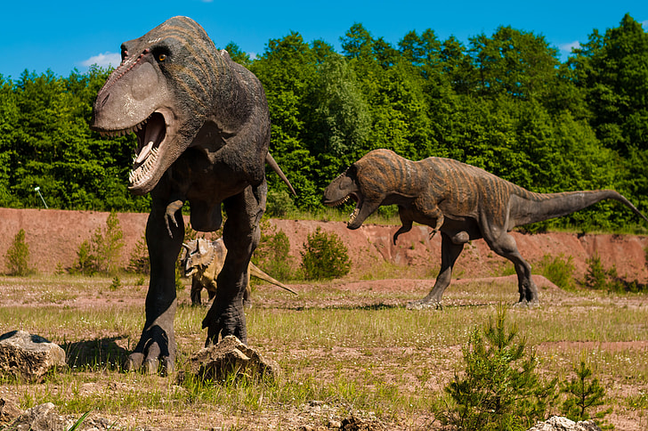
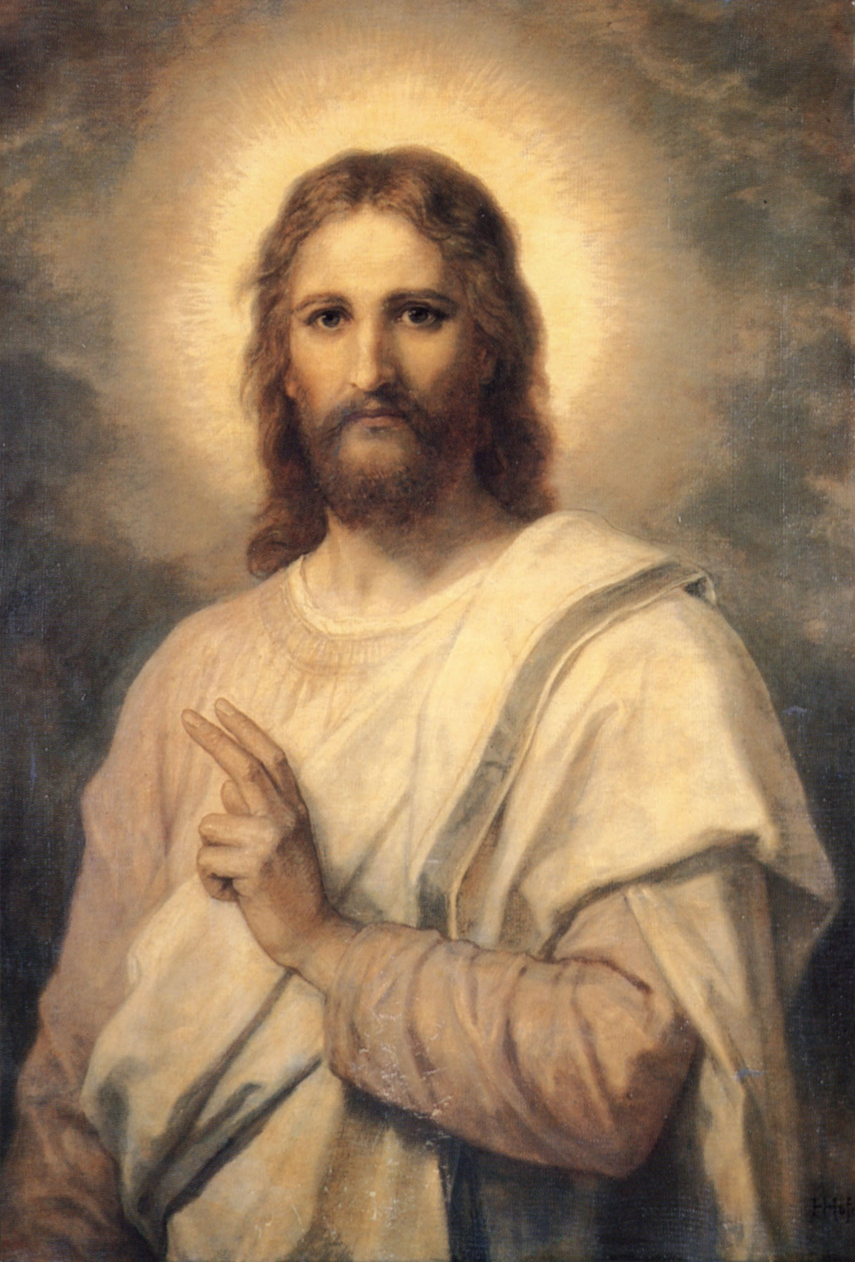
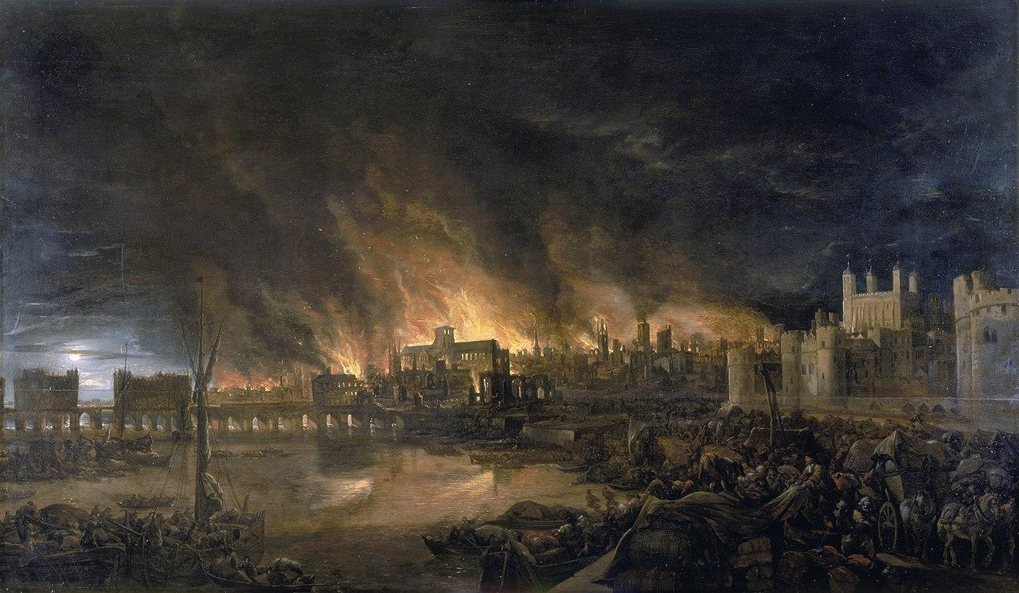
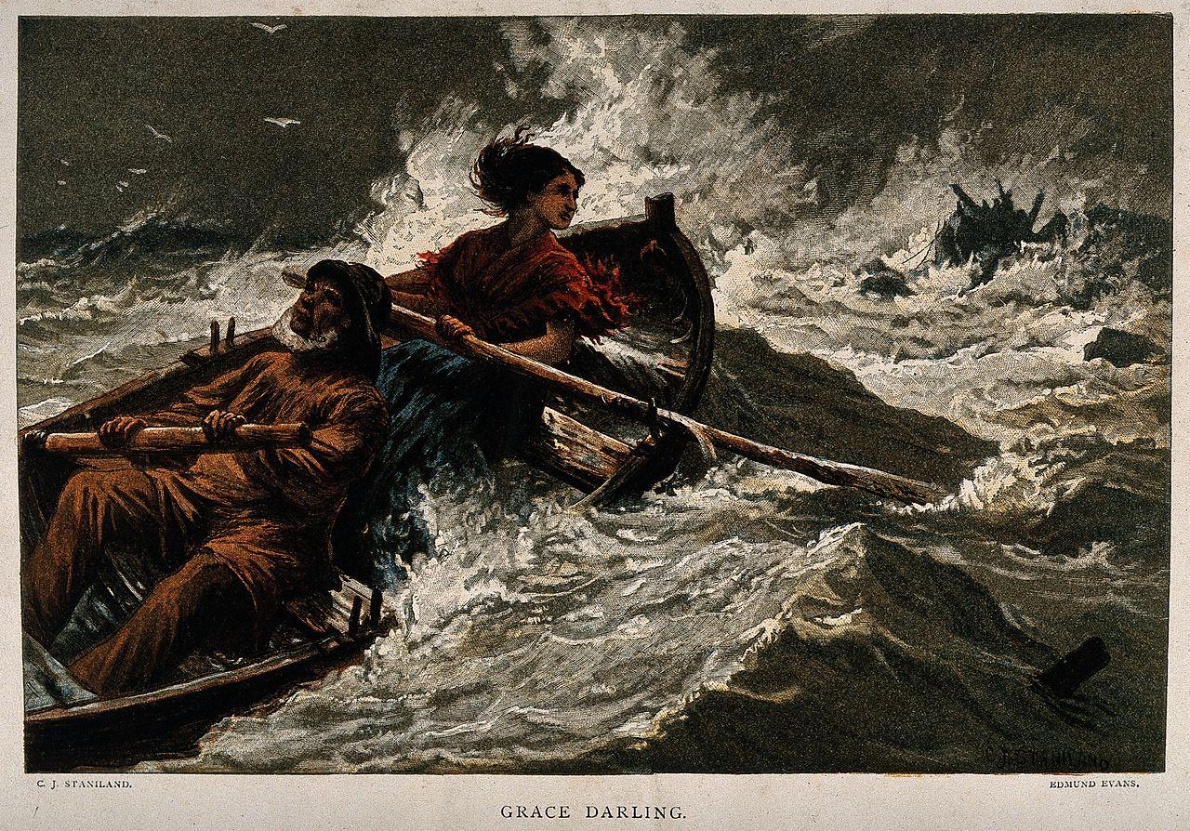
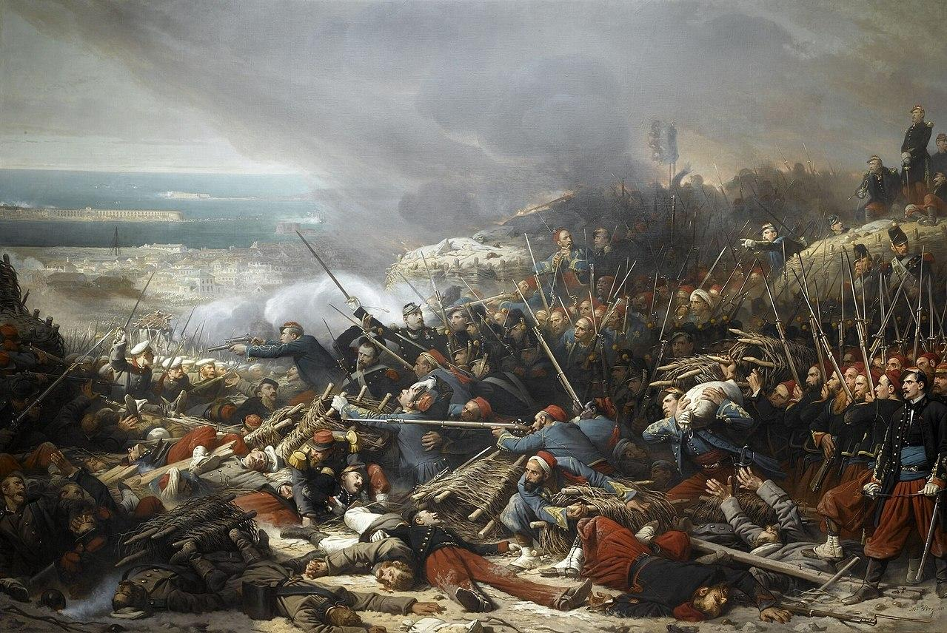

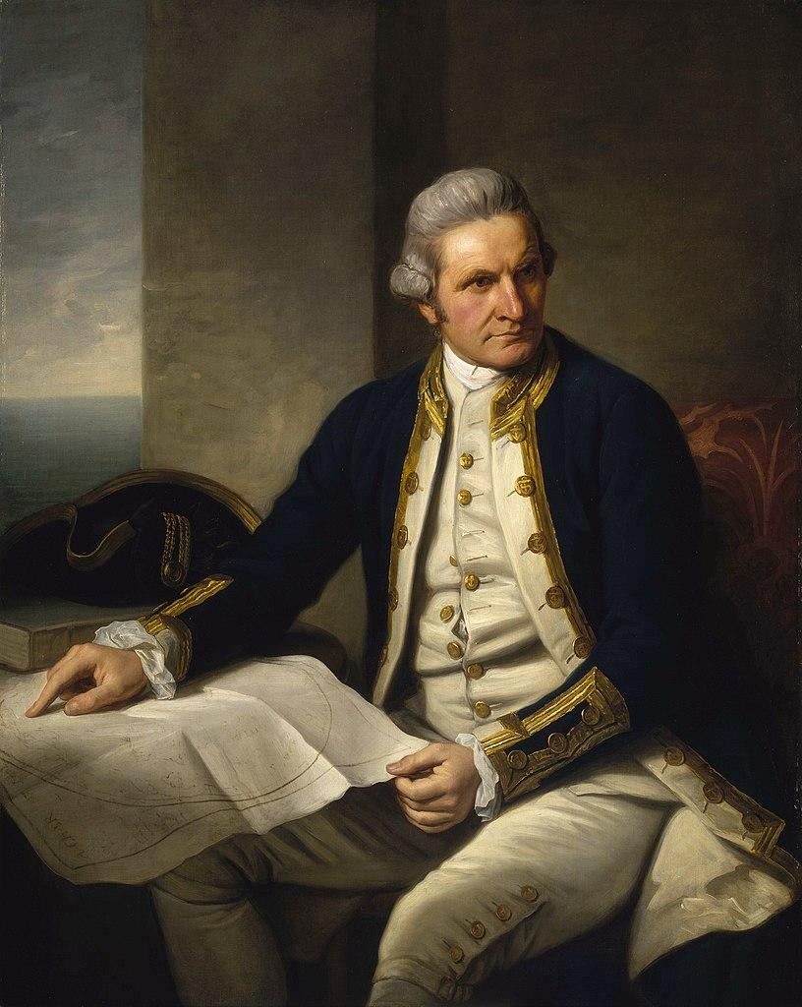
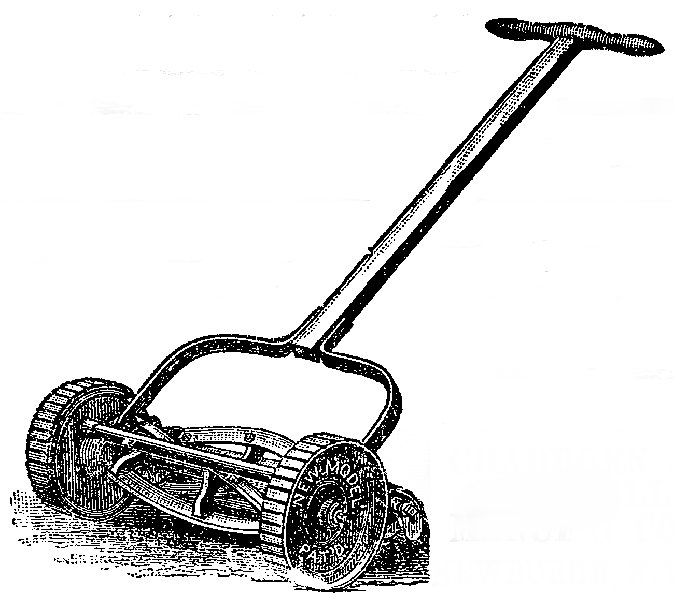
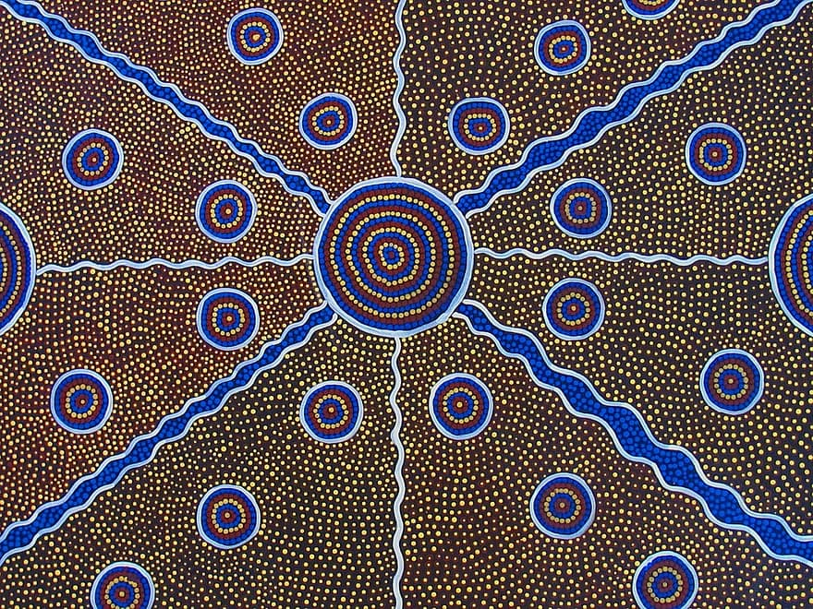
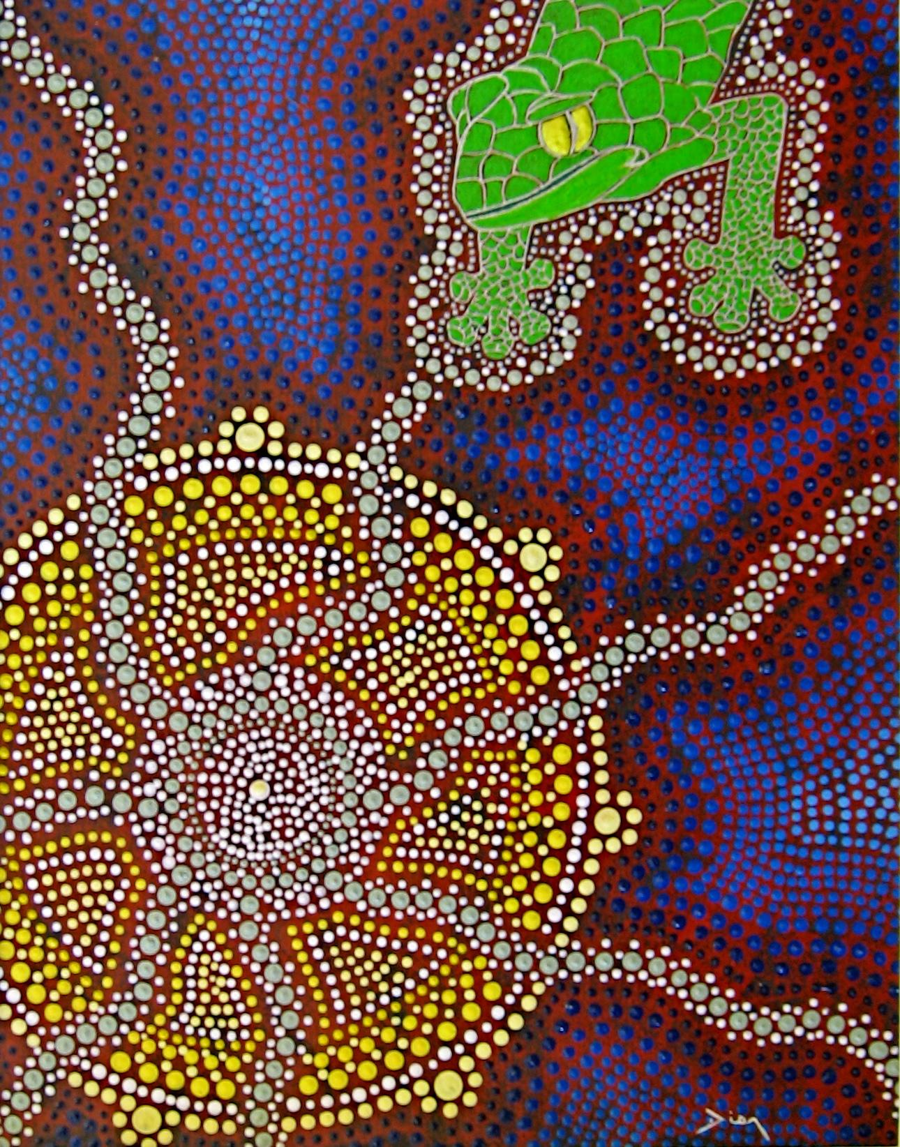
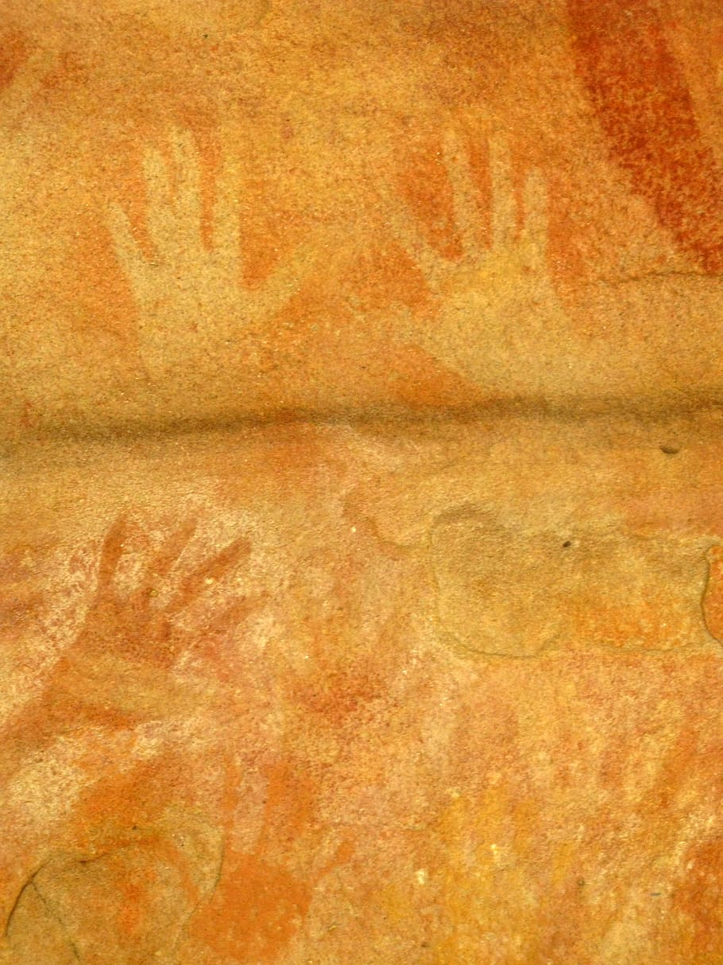
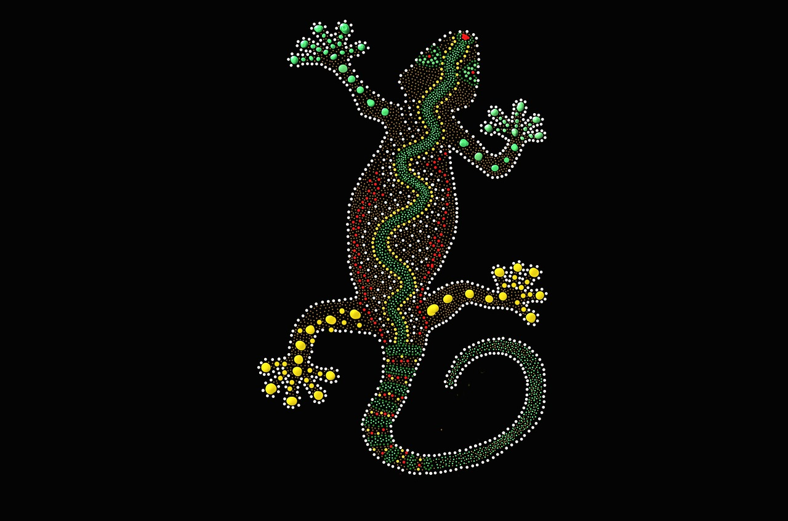
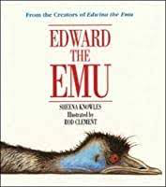
Modern Day (2022)
The Crimean War (1853 - 1856)
Grace Darling (1813 - 1842)
The Great Fire of London (1666)
Jesus (1 AD)
Dinosaurs (66 million years ago)
Edward Budding (1796 - 1846)
Captain James Cook (1728 - 1779)
Key Texts
Physical features
beach
lake
mountain
desert
island

