Y1 READING LIST
Our Core Texts:
These are the books that we will be exploring in the classroom.
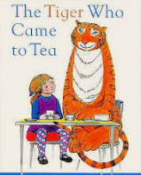  The Tiger Who Came to Tea  Judith Kerr | A little girl named Sophie is having tea with her mother in their kitchen when she hears the doorbell ring. Soon, Sophie and her mother are joined for tea by a kind tiger who drinks all the tea before eating all the food in the house and then drinking everything, even draining all the water from the taps.
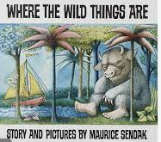  Where the Wild Things Are  Maurice Sendak | Max, a wild and naughty boy, is sent to bed without his supper by his exhausted mother. In his room, he imagines sailing away to a land of Wild Things. Instead of eating him, the Wild Things make Max their king.
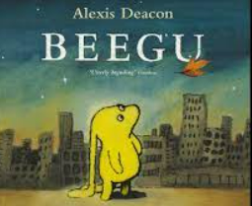  Beegu  Alexis Deacon | Beegu is not supposed to be on Earth. She is lost. She is a friendly little creature but the Earth people don’t seem very welcoming at all. However, so far she has only met the BIG ones. The little ones are a different matter.
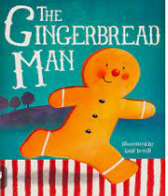  The Gingerbread Man  Louise Martin | “Run, run as fast as you can. You can’t catch me, I’m the Gingerbread Man!”  This book follows the story of a man and his journey running from the old lady, pig, cow, horse and fox.
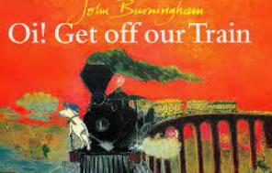  Oi! Get Off Our Train  John Burningham | A little boy sets off on a round-the-world night train to Dreamland with only his toy dog for company. But soon all sorts of endangered animals are asking if they can jump on and join them on their journey…
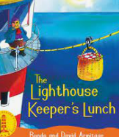  The Lighthouse Keeper’s Lunch  David Armitage | Every day Mr Grinling tucks into a delicious lunch, prepared by his wife, Mrs Grinling. But Mr Grinling isn’t the only one who enjoys the tasty food so Mrs Grinling has to think of a way to stop the greedy seagulls from stealing the lighthouse keeper’s lunch.
Other Books You May Enjoy:
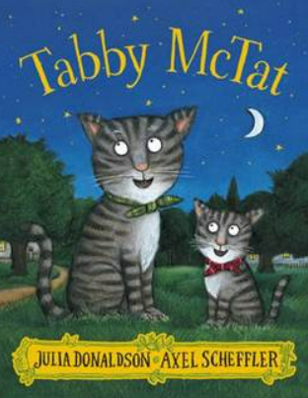  Tabby McTat  Julia Donaldson | Tabby McTat is a purr-fectly happy busker’s cat, until one day he falls in love with Sock, a gorgeous green-eyed cat.  But when his busker Fred is hurt and taken away to hospital, Tabby can’t find him and misses him terribly
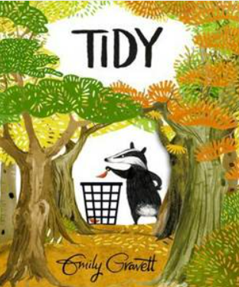  Tidy  Emily Gravett | Pete the badger likes everything in the forest to be neat and tidy. He snips off flowers that don’t match, washes the birds, vacuums the forest floor and sweeps, scrubs and polishes until everything is spick and span. As the autumn leaves fall, he swiftly scoops them up into a mountain of refuse bags. Then, deciding the bare trees look unsightly, he digs them up.
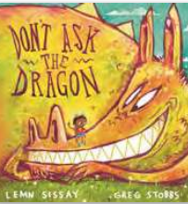  Don’t Ask the Dragon  Lemn Sissay | It’s Alem’s birthday but he’s alone with no one to help him celebrate and he doesn’t know where home is. A bear, fox, treefrog, meerkat and bull dog don’t have any good advice, except to tell him not to ask the dragon…or he will be eaten!
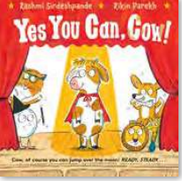  Yes You Can, Cow!  Rashmi Sirdeshpande | Rehearsals are underway for the big production of Hey Diddle Diddle but Cow is not ready for the spotlight. In fact – she’s absolutely terrified! She doesn’t think she’ll be able to nail the grand finale and jump over the Moon.
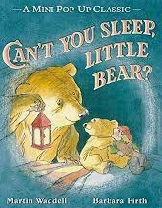  Can’t You Sleep, Little Bear?  Martin Waddell | Not even Big Bear’s biggest lantern can light up the darkness of the night outside. Can Big Bear find a way to reassure a restless Little Bear and help him fall asleep?
Authors to look out for:
- Julia Donaldson
- Martin Waddell
- Emily Gravett
- Oliver Jeffers
- John Burningham
- Jill Murphy
- Janet & Allan Ahalberg

