Year 2 Recommended Reading List

Core Texts
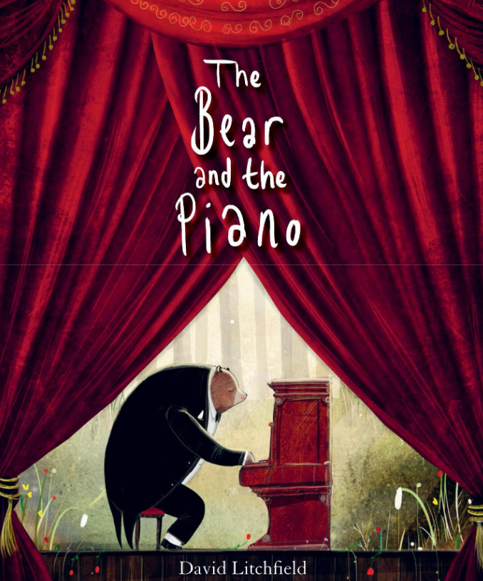 | The Bear and the Piano - David Litchfield  One day, a young bear stumbles upon something he has never seen before.. As time passes, he teaches himself how to play and eventually the beautiful sounds are heard by a father and son who are picnicking in the woods. | 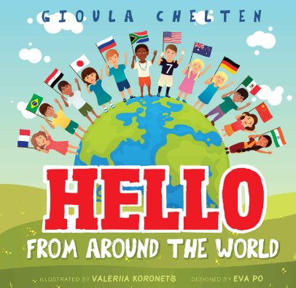 | Hello From Around the World - Gioula Chelten  With awareness of their cultural identity, the author delves into the lives of children from 12 countries around the world. It is a captivating picture book with bright and vivid colours.
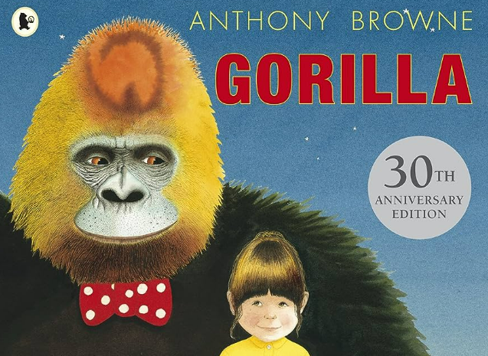 | Gorilla - Anthony Browne  Hannah loves gorillas but has never seen one. For her birthday, Hannah asks her father for a gorilla then something extraordinary happens ... the toy turns into a real gorilla, | 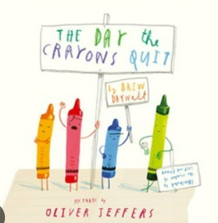 | The Day the Crayons Quit - Oliver Jeffers  Poor Duncan just wants to colour in. But when he opens his box of crayons, he only finds letters, all saying the same thing: We quit!
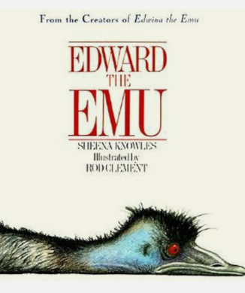 | Edward the Emu - Sheena Knowles  Tired of his life as an emu, Edward decides to try being something else for a change.But Edward soon discovers that being an emu may be the best thing after all. | 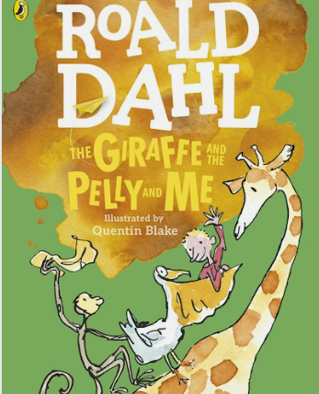 | The Giraffe, the Pelly and Me - Roald Dahl  The giraffe, the pelican and the agile monkey set out to prove that they are the best window-cleaning company around.
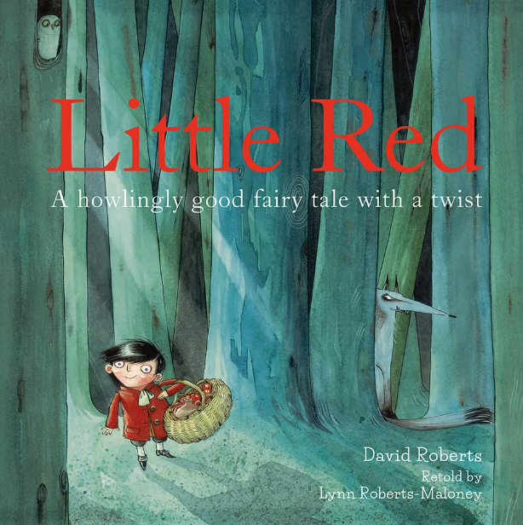 | Little Red - Lynn Roberts  Little Red is on his way to visit his grandmother on the other side of the wood. Ignoring all warnings of wolves in the wood, he removes his coat and strays from the path. That’s when the greedy wolf, lurking in the wood, hatches an evil plan | 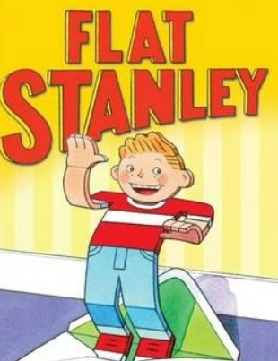 | Flat Stanley - Jeff Brown  Stanley Lambchop is an ordinary boy with an extraordinary problem. One night, a giant pinboard falls on top of him leaving him completely flat. But it's not always easy being different, and, once the novelty begins to wear off, Stanley wishes he could be just like everybody else again.
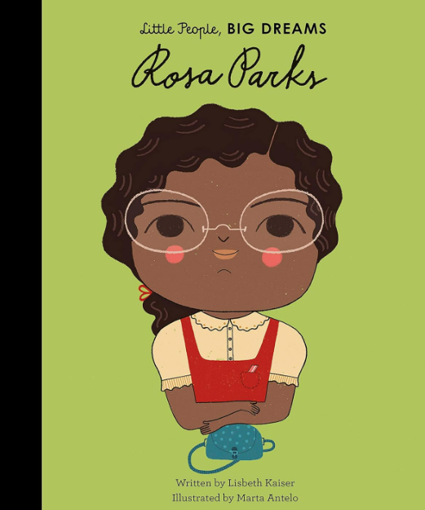 | Rosa Parks - Lisbeth Kaiser  Discover the incredible life of Rosa Parks, ' The Mother of the Freedom Movement'. In this true story of an inspiring civil rights activist, Rosa Parks grew up during segregation in Alabama, but she was taught to respect herself and stand up for her rights. | 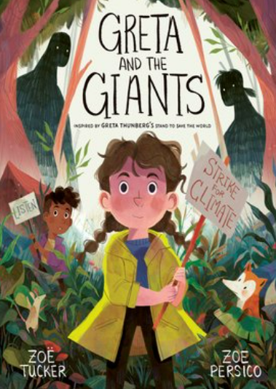 | Greta and the Giants - Zoe Tucker  When the Giants first came to the forest, they chopped down trees to make houses. Then they chopped down more trees and made even bigger homes, until now there is hardly any forest left. Greta knows she has to help the animals who live in the forest, but how? Luckily, Greta has an idea…

Recommended Texts
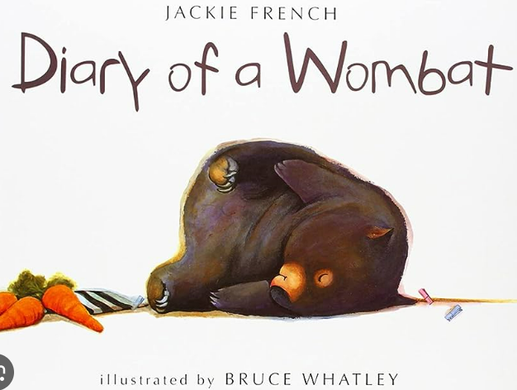 | A Diary of a Wombat -  Jackie French  Take a trip with a wombat, there are holes to be dug and territory to be defended – and don’t forget all the eating and sleeping that needs to be squeezed in too! | 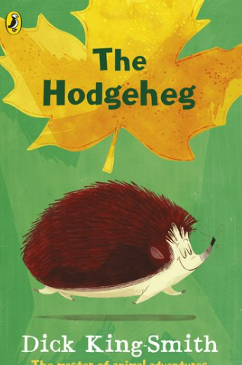 | The Hodgeheg - Dick King Smith  Max is a hedgehog who lives on the wrong side of the road from the Park. The busy road is dangerous and his first attempt ends in a nasty bump on the head. Max finds when he tries to speak his words are all mixed up.
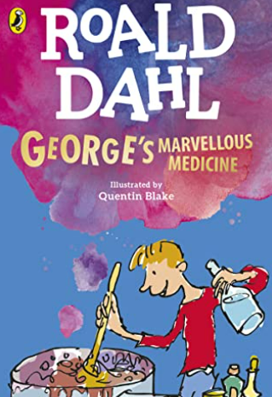 | George’s Marvellous medicine - Roald Dahl  George Kranky, an eight-year-old boy concocts his own miracle elixir to replace his tyrannical grandmother's regular prescription medicine. | 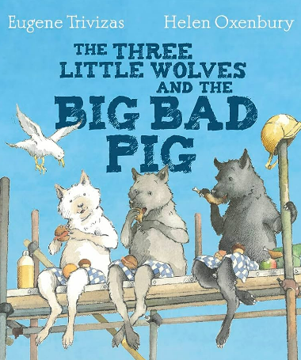 | The Three Little Wolves and the Big Bad Pig - Eugene Trivizas  A picture book that is a comically inverted version of the classic Three Little Pigs, a traditional fable published in the 19th century.
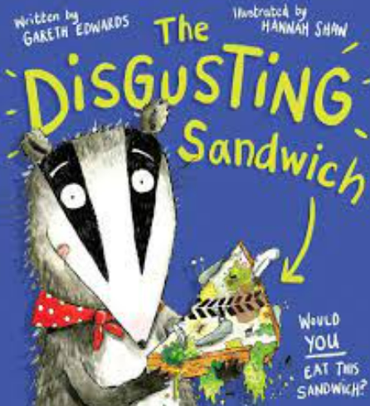 | The Disgusting Sandwich - Gareth Edwards  One day, a boy drops his sandwich in a sandpit, and the race is on! A very hungry badger wants it, but he's just not quick enough. The sandwich is dropped, squashed and slithered over by everyone. Will the badger ever get his paws on that sandwich? | 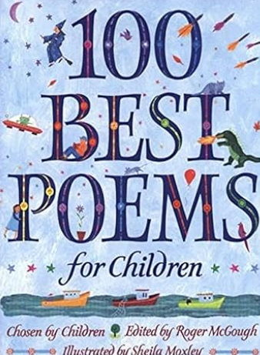 | 100 Best Poems for Children - Roger McGough  A collection of contemporary and classic poems chosen by children around the UK. Roger McGough made the final selection and wrote the introduction
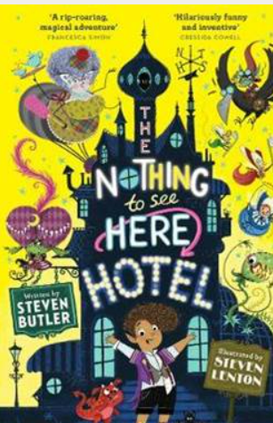 | The Nothing to See Here Hotel - Steven Butler  Frankie and his family run a Hotel, which is hidden by magic. However, one day, a messenger announces that the family have 24 hours to prepare for the arrival of the Goblin prince Grogbah. When rude Grogbah arrives, he brings with him more chaos than anyone could have expected. | 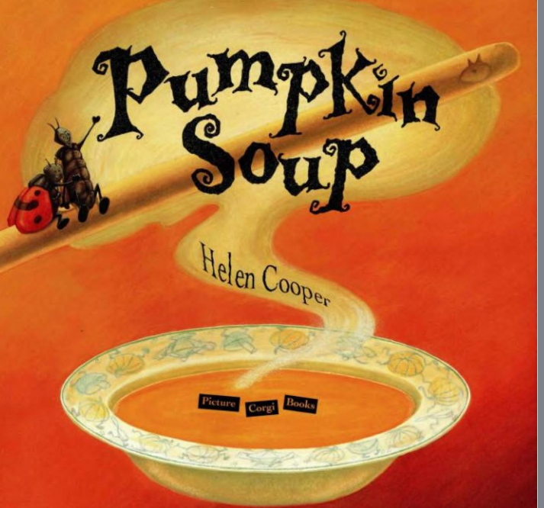 | Pumpkin Soup - Helen Cooper  The Cat and the Squirrel come to blows with the Duck in arguing about who will perform what duty in preparing their pumpkin soup.
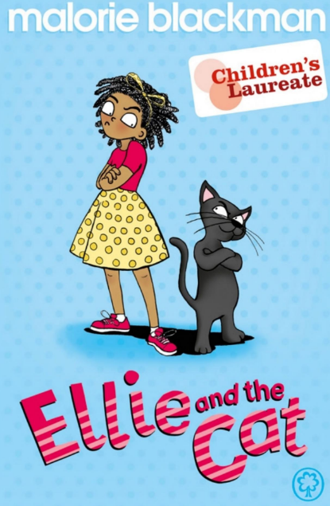 | Ellie and the Cat - Malorie Blackman  Ellie is the rudest, most spoilt child her grandma has ever met. So Grandma, who is a little bit magic, decides to teach her a lesson and switches Ellie's body with Jolly the cat's. | 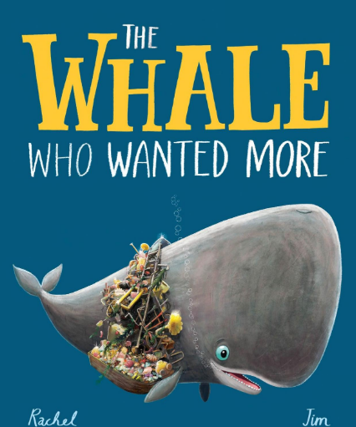 | The Whale Who Wanted More - Rachel Bright  Under glittering waves of a vast ocean blue, a beautiful world is hidden from view. And there, in the cool and the quiet of the deep, a great, gentle giant was stirring from sleep . . .A stunning undersea tale of friendship, community and discovery

Other Recommended Texts

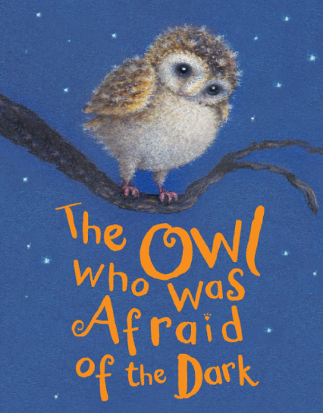 | The Owl Who was Afraid of the Dark - Jill Tomlinson | 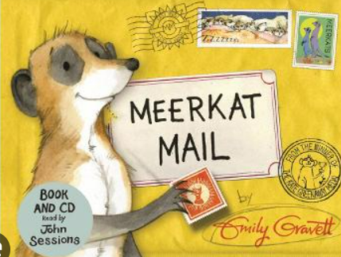 | Meerkat Mail - Emily Gravett
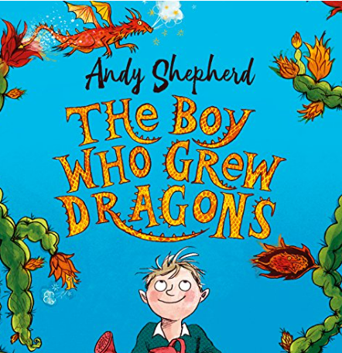 | The Boy Who Grew Dragons - Andy Shepard | 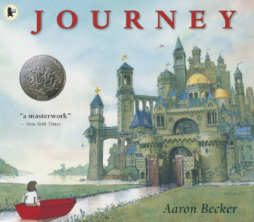 | Journey - Aaron Becker
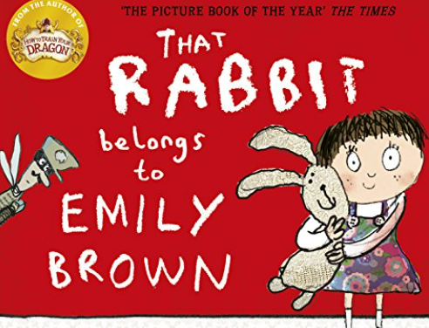 | That Rabbit Belongs to Emily Brown - Cressida Cowell | 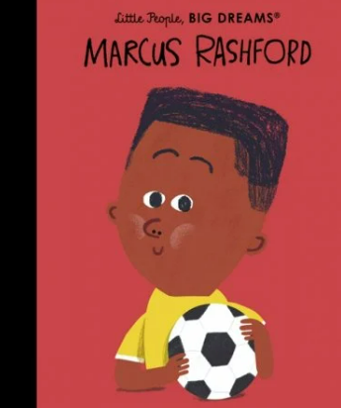 | Marcus Rashford - Maria Isabel Sanchez Vegara
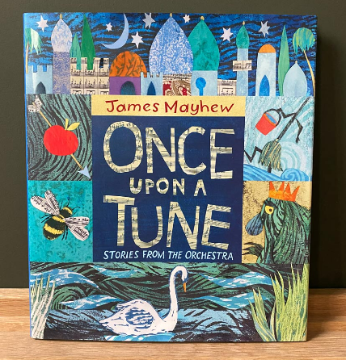 | Once Upon a Tune - James Mayhew | 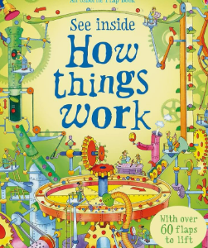 | How Things Work - Conrad Mason
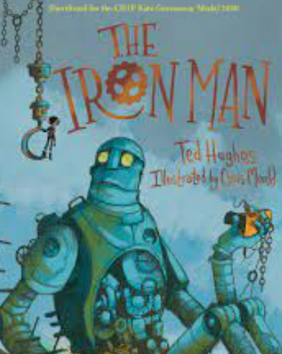 | The Iron Man - Ted Hughes | 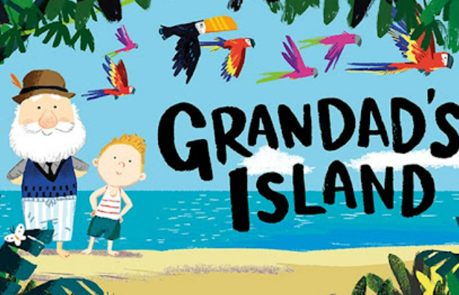 | Grandad’s Island - Benji Davies
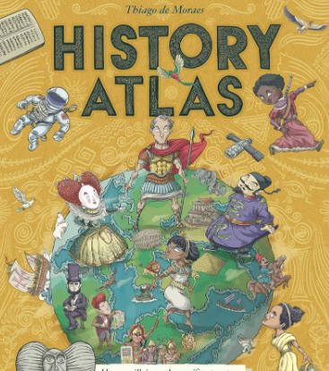 | History Atlas - Thiago De Moraes | 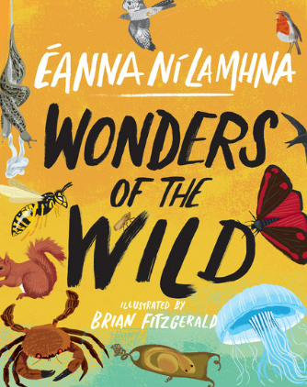 | Wonders of the Wild - Eanna Ni Lamhna
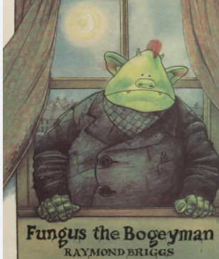 | Fungus the Bogeyman - Raymond Briggs | 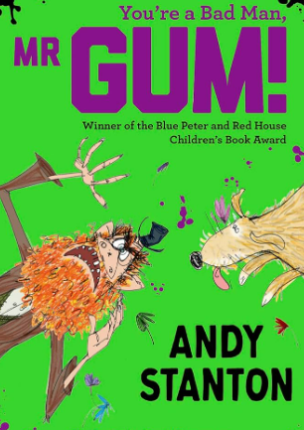 | You’re a Bad Man, Mr Gum - Andy Stanton
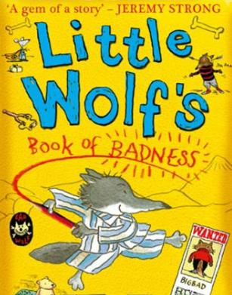 | The Little Wolf’s Book of Badness - Ian Whybrow | 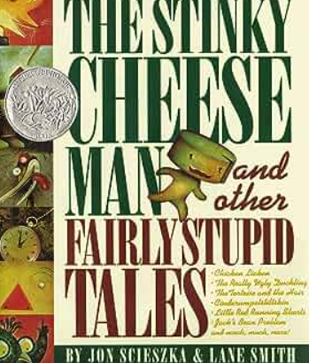 | The Stinky Cheese Man and other Fairly Stupid Tales

