Mr Burley’s Top Picks

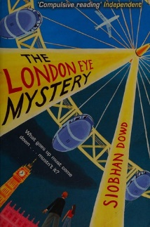  London Eye Mystery by Siobhan Dowd | Core Reading text (Term 1):  The late, great Siobhan Dowd’s ingenious ‘howdunit’ combines a meticulously constructed plot with a brilliantly memorable juvenile sleuth to create one of the standout children’s books of the twenty-first century. Engaging and rewarding, The London Eye Mystery is a junior crime novel par excellence.
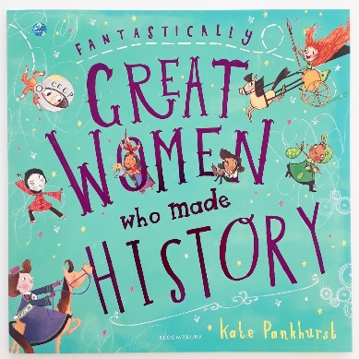  Fantastically Great Women Who Made History by Kate Pankhurst | Core Reading text (Term 2):  This beautiful title looks at the stories, accomplishments and adventures of many more brilliant women from throughout history. Travel through the Underground Railroad with the brave and courageous Harriet Tubman, turn the pages of the hauntingly brilliant Frankenstein with the incredibly talented Mary Shelley and prepare yourself for an unforgettable journey through history with these and many other remarkable women.
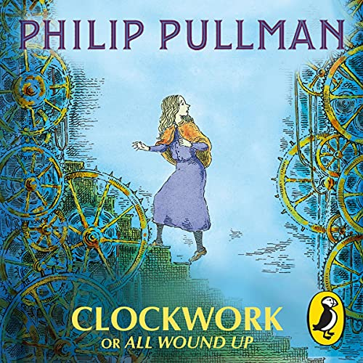  Clockwork by Phillip Pullman | Core reading text (Term 3):  Tick, tick, tick, tock. Once you've wound some things up nothing can stop them . . .  It is a cold winter's night when Karl enters the White Horse Tavern looking like he's swallowed a thundercloud. His final task as a clockmaker apprentice is to make a new figure for the great clock of Glockenheim. He has not made the figure - or got any idea of what it could be, and the unveiling is tomorrow.
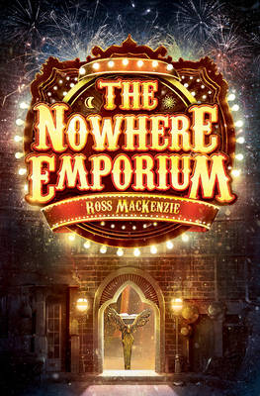  The Nowhere Emporium by Ross Mackenzie | Core reading text (Term 4):  When the mysterious Nowhere Emporium arrives in Glasgow, orphan Daniel Holmes stumbles upon it quite by accident. Before long, the 'shop from nowhere' -- and its owner, Mr Silver -- draw Daniel into a breathtaking world of magic and enchantment.  Recruited as Mr Silver's apprentice, Daniel learns the secrets of the Emporium's vast labyrinth of passageways and rooms -- rooms that contain wonders beyond anything Daniel has ever imagined.  But when Mr Silver disappears, and a shadow from the past threatens everything, the Emporium and all its wonders begin to crumble.  Can Daniel save his home, and his new friends, before the Nowhere Emporium is destroyed forever?
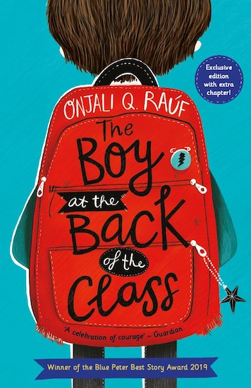  The Boy at the Back of the Class by Onjalia Q Rauf | Core text (Term 5)  Based in part on the stories she encountered when working in refugee camps, Onjali Q. Raúf’s remarkable debut deserves to be ranked as a modern classic. Told with humour and tenderness, it is an unforgettable story of hope, curiosity and the importance of kindness.
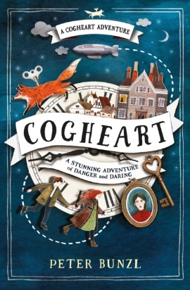  Cogheart by Peter Bunzl | Core text (Term 6)  A deliciously atmospheric slice of junior steampunk, Bunzl's fantastical tale of mechanical foxes, missing fathers and mysterious zeppelin crashes abounds in wit, invention and adventure.
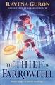  The Thief of Farrowfell by Ravena Guron | Welcome to a fantasy world where edible magic is the hottest commodity, traded between those who can pay or – in the case of Jude Ripon, the youngest thief in Farrowfell – those who can steal it! An epic debut series from the FAB prize winner.
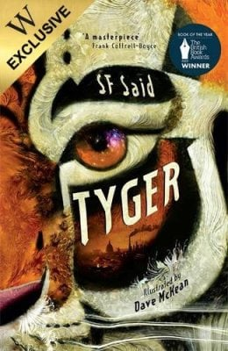  Tyger by S.F Said | Adam has found something incredible in a rubbish dump in London. A mysterious, mythical, magical animal. A Tyger. And the tyger is in danger.  Adam and his friend Zadie are determined to help, but it isn't just the tyger's life at stake. Their whole world is on the verge of destruction. Can they learn to use their powers before it's too late?
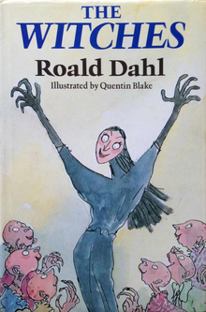  The Witches by Roald Dahl | "One child a week is fifty-two a year. Squish them and squiggle them and make them disappear."  This is a story about REAL WITCHES.  Real witches dress in ordinary clothes, have ordinary jobs and look very much like ordinary people.  But they are far from ORDINARY . . .
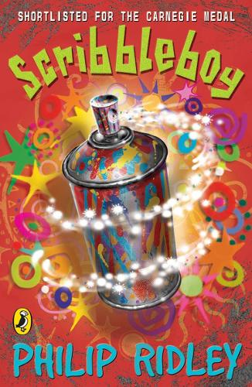  Scribbleboy by Phillip Ridley | Bailey arrives in a new neighbourhood with his extraordinary family. He has no friends but receives a mysterious invitation to join the Scribbleboy Fan Club. The one and only founder member is Ziggy Fuzz. His vital mission is to spread the word about Scribbleboy and his amazing scribbles which years ago transformed the gloomy grey concrete of the neighbourhood. Swept along in plans to discover the identity of the mythical artist, Bailey carries on his work so the scribbles start again and eventually he discovers the scribbleboy is in fact a scribblegirl!
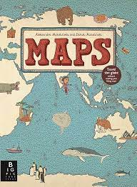  Maps by Aleksandra Mizielinska Daniel Mizielinkski | Explore the world with this lavish book of maps. This collection of 52 highly illustrated maps details not only geographical features and political borders, but also places of interest, iconic personalities, native animals and plants, local peoples, cultural events, and many more fascinating facts associated with each region.  This book is a celebration of the world, from its immense mountains to its tiny insects - and everything in between!
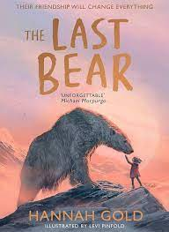  The Last Bear by Hannah Gold | Both absorbing animal adventure and subtle commentary on climate change and the plight of endangered species, The Last Bear revolves around April, the daughter of an Arctic researcher, and her chance encounter with a lone polar bear.  There are no polar bears left on Bear Island. At least, that's what April's father tells her when his scientific research takes them to this remote Arctic outpost for six months. But one endless summer night, April meets one. He is starving, lonely and a long way from home. Determined to save him, April begins the most important journey of her life...
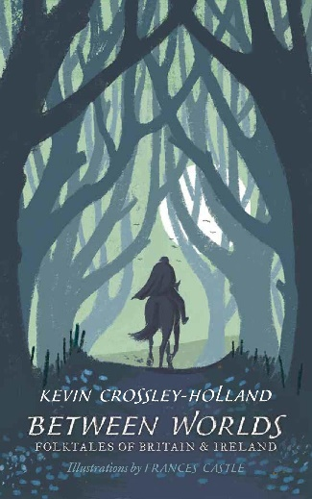  Between Worlds: Folktales of Britain and Ireland by Kevin Crossley-Holland | The definitive collection of British and Irish folktales from master storyteller and poet Kevin Crossley-Holland.  Rich and strange, these eerie and magical folktales from across Britain and Ireland have been passed down from generation to generation, and are gathered together in a definitive new collection from the master storyteller and winner of the Carnegie Medal, Kevin Crossley-Holland. Dark and funny, lyrical and earthy, these fifty stories are part of an important and enduring historical tradition that dates back hundreds of years. Described by Neil Gaiman as the "master", Crossley-Holland's unforgettable retellings will capture the imagination of readers young and old alike.
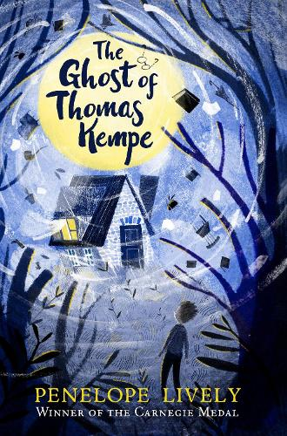  The Ghost of Thomas Kempe by Penelope Lively | The classic ghost story from Penelope Lively, one of the modern greats of British fiction for adults and children alike.  James is fed up. His family has moved to a new cottage - with grounds that are great for excavations, and trees that are perfect for climbing - and stuff is happening. Stuff that is normally the kind of thing he does. But it's not him who's writing strange things on shopping lists and fences. It's not him who smashes bottles and pours tea in the Vicar's lap. It's a ghost - honestly. Thomas Kempe the 17th century apothecary has returned and he wants James to be his apprentice. No one else believes in ghosts. It's up to James to get rid of him. Or he'll have no pocket money or pudding ever again.  An iconic ghost story for children, The Ghost of Thomas Kempe is adored by generations of readers.
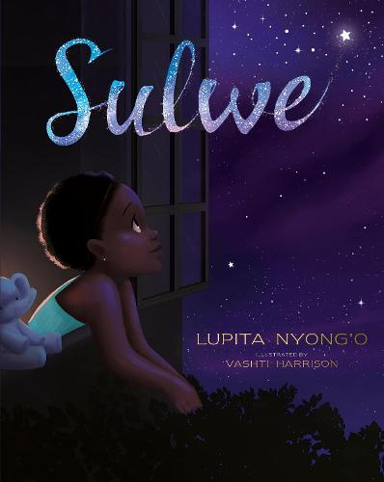  Sulwe by Lupita Nyong’o | From Academy Award-winning actress Lupita Nyong'o comes a powerful, moving picture book about colourism, self-esteem and learning that true beauty comes from within.  Sulwe's skin is the colour of midnight. She's darker than everyone in her family, and everyone at school.  All she wants is to be beautiful and bright, like her mother and sister.  Then a magical journey through the night sky opens her eyes and changes everything.  In this stunning debut picture book, Lupita Nyong'o creates a whimsical and heartwarming story to inspire children to see their own unique beauty.
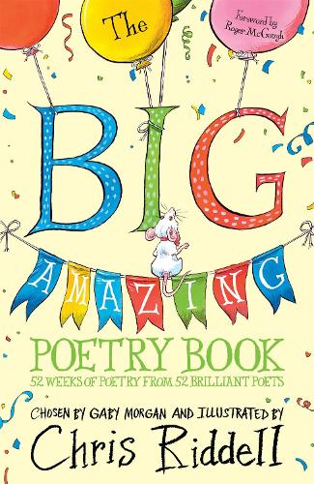  The Big Amazing Poetry Book by Roger McGough | From John Agard and Julia Donaldson to Nikita Gill, Brian Bilston and Carol Ann Duffy, The Big Amazing Poetry Book is a brilliant, accessible introduction to poetry and to fifty-two fantastic poets.  Introduced by Roger McGough, the book features the illustrations of 2015–2017 Children's Laureate and beloved author of the Goth Girl and Ottoline series, Chris Riddell.  A warm, funny collection, this book is packed with many different styles of poetry – ballads, riddles, tongue-twisters, shape poems, haikus, sonnets and raps – about seasons, festivals, animals, birds, love, war, food, fish and football and much more.
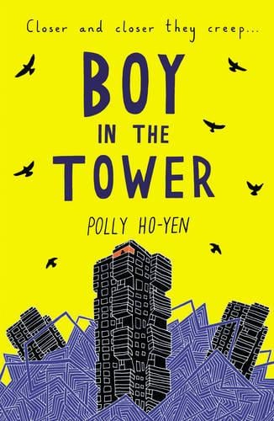  Boy in the Tower by Polly Ho-Yen | Tackling themes of anxiety and agoraphobia with sensitivity and sure-footedness, Ho-Yen's masterful novel mixes urban realism with science fiction as strange plants cause tower blocks to tumble all around Ade and his mother.  Ade loves living at the top of a tower block. From his window, he feels like he can see the whole world stretching out beneath him. His mum doesn't really like looking outside - but it's going outside that she hates. She prefers to sleep all day inside their tower, where it's safe.  Except it isn't any more. Strange plants have started to take over and tower blocks are falling down around them. Now Ade and his mum are trapped and there's no way out.
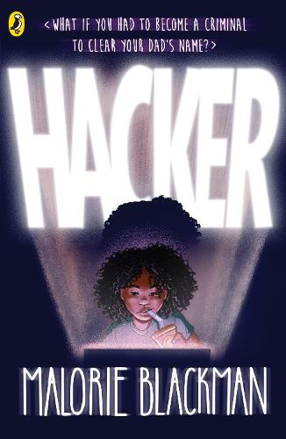  Hacker by Malorie Blackman | Vicky's life is completely normal. Maybe even a little boring.  But all that changes when her dad is accused of stealing a million pounds from the bank where he works.  Vicky knows for sure that her dad is innocent, and is determined to prove it.  Luckily for him, she is a seasoned computer hacker. Using the skills he taught her, she's going to attempt to break the bank's files. Should be simple, right?  But it's a race against time to find the cyber-thief, before they find her . . .
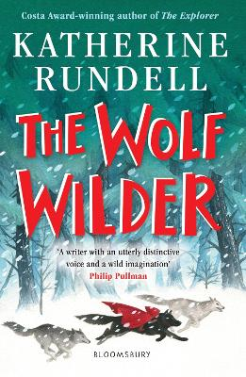  The Wolf Wilder by Katherine Rundell | Set in the snowy forests of Russia, this enchanting story from the Waterstones Children’s Book Prize-winning author about a girl and her mother who teach wolves to fend for themselves against hostile humans sends a powerful message about fighting for what you love.
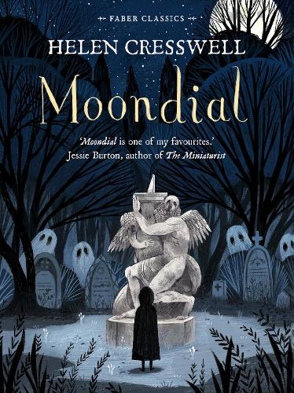  Moondial by Helen Cresswell | Even before she came to Belton, Minty Cane had known that she was a witch, or something very like it . . .  Minty is the kind of girl who notices things. Pockets of cold air on a stairway. Cries on the wind. Ghosts.  On night-time jaunts from the house where she's staying while her mother recovers from an accident, Minty stumbles upon a moondial which takes her back in time. She finds Tom, a sickly kitchen boy, and Sarah, a girl with a birthmark who is only allowed out at night because her family think she has the mark of the devil . . .

